**Troy Filipcevic** is Founder and CEO of Emergence, an underwriting agency 100% focusing on providing insurance solutions for Cyber risks. Emergence has a presence in Australia and New Zealand and won the Underwriting Agency of the Year award for 2019.

Previously to starting Emergence, Troy held executive roles at Suncorp and was Head of Strategy. He also held roles in Partnering & Operational Excellence that was responsible for improving business performance and also the Technology business focused on designing and implementing the technology strategy.

Prior to joining Suncorp, Troy worked as a management consultant for Deloitte and has a background in Innovation and Corporate Strategy. During that time, he managed the internal innovation program as well as consulting to businesses on innovation, strategy and operations.

Troy is a qualified Mechanical Engineer, holds a Bachelor of Business and an MBA from the Australian Graduate School of Management (AGSM).

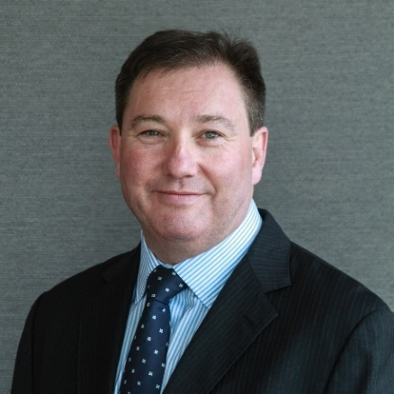**Colin Fagen** is the founder and Managing Director of Blue Zebra Insurance. BZI is an Insurtech Underwriting Agency that has built its own proprietary system and grown over five years to have a turnover in excess of $200m and 40 staff, servicing the intermediary market in both personal and commercial lines products.

Colin has extensive experience in Insurance with over 30 years participation at all levels in the Australian and global market. This accumulated experience is complimentary to the activities undertaken by individual Agencies and the UAC Board. He has held global C-suite roles including Chief Operations Officer, Chief Strategy Officer and CEO Australia and New Zealand for QBE Insurance. Other roles have included being the President and Vice President of the Insurance Council of Australia, Board member of ANZIIF and has sat on the Boards in various industry and private company organisations.

This experience involved dealing with all levels of local, state and federal government on a multitude of insurance issues, dealing with a large number of Agencies as an underwriter, operator, shareholder, Board member, Responsible Manager and purchaser and seller. He has extensive networks throughout the industry worldwide.

Colin is passionate about nurturing and supporting talent in the insurance industry. He actively seeks to drive a supportive team culture and to drive innovation in the businesses in which he works and the broader insurance industry.

Colin has a Batchelor of Economics, an MBA, is an ANZIIF Affiliate and a Graduate of the Australian Institute of Company Directors.

Colin is committed to strengthening the UAC through making the network stronger and listening to the views of agencies to enhance the service that the UAC delivers to its members.

**Hamish McDonald-Nye**, is Executive Director of Professional Risk Underwriting Pty Ltd (“ProRisk”) and Armada Underwriting Pty Ltd following a successful career in underwriting and insurance broking and management.

His experience includes business management, underwriting, insurance broking, technology platform development, portfolio management, education and training, product design, and compliance.

As Executive Director of ProRisk and Armada underwriting agencies Hamish has transformed a traditional underwriting business into a technology enabled, multiline underwriting business focused on the needs of SME and mid-market insureds with offices in Melbourne, Sydney and Brisbane.

Under Hamish’s stewardship the business made significant investments in technology, marketing, and people. He has managed the business through a cyber attack, successfully rebranded ProRisk, restructured the business’ capacity arrangements, launched new products and refreshed its full product suite.

A key achievement of has been the development of the ‘ProBind’ underwriting platform which enables its 5,000 users to quote bind and endorse a policy online anywhere in minutes. The platform is also enabled to support insuretechs and broker platforms through multiline API’s.

Education and professional development are a passion for Hamish, who has delivered 100 free educational seminars to the market via webinar and handing out over 20,000 CIP/CPD Points to brokers.

Hamish has led ProRisk to win a number of awards including Insurance Business Award’s Underwriting Agency of the Year in 2020 and ANZIIF’s Most Valuable Team for 2021 for ProRisk’s Claims team.

Hamish holds a Bachelor of Economics (Hons) from Monash University and Diploma of Financial Services (Insurance Broking). Hamish is a member of the Australian Professional Indemnity Group and the Australian Law Association and regularly participates on industry panels including as a keynote speaker during the state of the market address at the 2022 APIG National Conference.

**Matt Porteous** is the Head of Partnerships & Engagement at Market Lane Insurance Group. Originally established in 2019 as ‘The Barn Underwriting Agency’, Market Lane is a privately owned and operated commercial insurance underwriter based in The Rocks, Sydney. Market Lane has a simple mission - “to create a world-class diversified insurance underwriting and distribution business for today and tomorrow”

Matt is a relatively new face to the Insurance Industry, joining Market Lane in September 2020 after a successful 15-year career in the Food & Beverage sector. Most notably as a National Account Manager for some of Australia’s largest hospitality and leisure venues hosting some of the world’s biggest and most exciting events.

Matt is a naturally energetic and enthusiastic business leader who has enjoyed the challenge of learning the insurance ropes in recent years, whist applying his unique sales and marketing experiences to build and establish the Market Lane Group brands, including The Barn, G.O.A.T Insurance and Fairlight Medical with a dynamic pipeline of projects to come!

Many in the industry have met Matt as the ‘man at the stand’ representing Market Lane Insurance Group at all UAC expos and numerous industry events around Australia and he is truly excited to bring the same fresh approach, enthusiasm and unique experience to the UAC Board of Directors and entire UAC community.

**Alan Brett,** recently arrived in Australia from the UK I’m a new ‘old’ face in the market.

After spending 20+ years within the company market, I wanted more scope and the ability to shape a culture. Working with people passionate about doing the right thing is positively infectious, and I’m loving the last two years in the Underwriting Agency space.

Helping lead a growing business gives me a deeper and wider insight into agency management. After 25 years in the game, I have both the experience and a contemporary view of the Australian market which makes for a strong addition to the board. I feel that representation of all agencies, no matter the size, is important to ensure the council truly reflects its membership.

What do I think I can bring to the board? In short, my passion, drive, and energy to improve the industry and deliver better outcomes for all customers through our membership. My mandate for election would be to deliver:

* Talent development – our industry is facing a crisis of resources. How can we attract talent into underwriting agencies and nurture it to create the next generation of insurance innovators? I’m keen to build a learning community through pooling resources that deliver development programs for all roles and experience levels.
* The risk of market failure is ever present – we must lobby legislators to ensure customers are not unprotected.
* Capacity management – UAC plays a pivotal role in helping members access capacity. Delivering consistent results deliver better outcomes for customers, brokers, and shareholders. I’m keen to build a mentor program to share best practices to help manage these critical relationships.
* Customer service – I’m proud of our industry, but its reputation is easily tarnished – We need to consistently shout about the good we do.

**Simon Lightbody**

Chief Executive Officer, Steadfast Underwriting Agencies Holdings Pty Ltd

Chief Executive Officer, Miramar Underwriting Agency Pty Ltd

Simon is Chief Executive Officer for Steadfast Underwriting Agencies and based in Sydney, Australia. Steadfast Underwriting Agencies was formed following the Steadfast Group IPO in August 2013. It has shareholding in 26 Underwriting Agencies in Australia covering multiple product classes and with a GWP of $914 million.

Simon started his insurance career with CT Bowring in London as an International Liability Broker in the Lloyd’s market in 1990. In 1995 Simon moved on to the underwriting side of the insurance business as a Liability Underwriter for various entities in the London and Lloyd’s market, including Eagle Star Re, Lloyd’s Syndicates at Amlin and Denham, and XL Insurance, specialising in underwriting liability programs in various territories including South Africa, Canada, Australia and Israel.

XL Insurance led Simon to Australia where he worked for 3 years as Liability Manager in the new XL operation. In 2005 he started Miramar Underwriting Agency, which in 2013 sold into the Steadfast IPO. Simon is still CEO of Miramar Underwriting Agency.

In December 2016 Simon was elected to the Board of Directors for the Underwriting Agencies Council.

**Jesse Borthwick** has more than 30 years’ experience in the insurance industry, including as a technical underwriter for a large strata underwriting agency and as a broker. He has also worked with strata management companies. Jesse is one of the most respected, highly sought-after technical property and strata underwriters in the Asia Pacific region. He holds underwriting authorities up to $350m ($100 PML). Jesse’s expertise is sought after by leading strata industry organisations and other property underwriting agents in Australia for his guidance and advice. Similarly, the intermediary market eagerly engages with Jesse to better understand their own portfolios.

Jesse has comprehensive experience in senior, technical and consultative roles. His underwriting and analytical skills have enabled him to develop strata-specific rating models, including tools that effectively manage strata risks above the 25th parallel. The is-Strata rating model is a bespoke application where each risk is underwritten by a person and priced on its individual merits. Multiple rating factors are considered for each risk.

Jesse has proven ability to manage large underwriting portfolios. He opened greenfield strata underwriting agency Longitude in 2012, which grew to more than $80m GWP.

His comprehensive understanding of the strata environment, experience in senior positions, and ability to develop rating models enable him to effectively balance the tensions between statutory requirements, portfolio management, underwriting guidelines, and the need to offer competitive, innovative products to the market.

Jesse’s understanding of the complex nature of pricing risk will enable IIS to become a market leader in the strata environment. While he predominantly focuses on IIS’s technical performance, Jesse is also actively involved in corporate management and strategic direction of the company.

**Heath Amber**

Heath Amber is seeking re-election to the Underwriting Agency Council (UAC) board. He has served the UAC community for nearly 15 years holding various board and committee positions, including Chair, Vice Chair and Public Officer. As a re-elected board member, Heath will continue working and advocating for all members as the industry continues to evolve into the future.

By way of background, Heath has worked in the insurance industry for more than 25 years with the last 15 years specialising in underwriting agencies, binders and wholesale placements.

Heath has extensive industry board experience including directorships with leading underwriting agencies and general insurance broking.

Heath is based in South Australia and champions national UAC board representation and membership. I look forward to working with UAC and its members.

**Emily Walker**

From broking in country Victoria straight out of high school in 1997, to being the Head of Strata & Development for Axis Underwriting today, Emily has always had a passion for the insurance industry and its people.

Emily has been with Axis since 2011 and worn a few hats, including spending 3 and a half of those years in Sydney setting up and running the branch there before returning to Melbourne at the end of 2017.

Axis is a leading Lloyd’s coverholder in Australia and very proud of its continued success in a challenging market.

“I love the camaraderie with our board members and the sense of community shared with the wider UAC family. After a tough couple of years, I really look forward to us working together and continuing to contribute to UAC’s future success.”

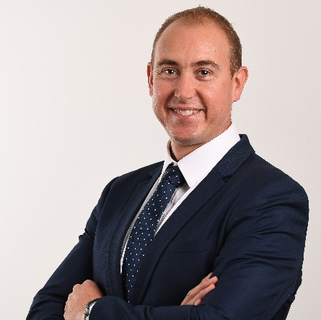 **Stephen Carey** is a co-founder and director of Delta Insurance Australia. Stephen started his insurance career in 2003 working for Zurich in London.

After moving to Australia in 2008, Stephen worked for over 10 years at Chubb where he managed the Queensland financial lines portfolio and also had roles managing key distribution relationships.

Stephen established Delta Insurance Australia in February 2022. Delta Insurance Australia is a specialist underwriting agency that forms part of the Delta Insurance Group.

Outside of work, Stephen’s passions are family and friends, running in crazy costumes and advocacy and fundraising for a range of charities.

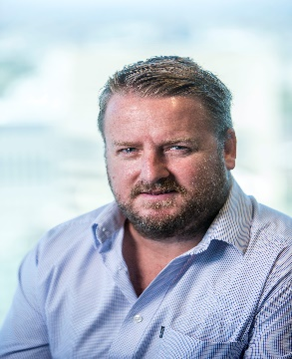

**Trent Brown** is the founding director of Allstate Underwriting which is a farm underwriting agency. And the current UAC treasurer. He started selling insurance out of rural merchandise stores in the late ‘90s while employed by AXA Insurance.

Before starting Allstate, he was a director and General Manager of Ausure Insurance Brokers, a business that started with one authorised representative in Tamworth and grew to 145 locations and $450 million in base premium. Trent was involved in mergers and acquisitions during that time and responsible for growth of the network as well as the many binding authorities on behalf of the brokerage.

He is a Certified Insurance Professional and Senior Associate of ANZIIF, a NIBA QPIB, and an Affiliate of the Australasian Institute of Chartered Loss Adjusters. He has a Diploma in Insurance Broking and a bachelor’s degree in health and human movement from the Australian College of Physical Education.

Outside of the insurance industry Trent operates a thoroughbred and cattle breeding operation in the Hunter Valley NSW.

**Richard Hardy** ANZIIF Snr.Assoc. Dip Fin Serv Insurance, Assoc Fellow of the Institute of Managers and Leaders.

Underwriting Director – Argenta Underwriting Australia

I have worked in the insurance industry for over 30 years. I commenced my career in the London market before migrating to Australia in the mid 90’s where I joined what was Commercial Union as their NSW Property Manager.

I have had the opportunity to have worked with some of the largest insurance organisations both domestic and international in underwriting and broking roles and have gained a significant amount of knowledge of underwriting property insurance and reinsurance business as well as being responsible for the management of other classes of business, construction, high net worth homeowners, accident and health. Also, broader management as NSW State Manager for ACE (now Chubb).

My exposure has been to underwrite major multinational organisations, large domestic companies and a very large number of small to medium enterprise businesses.

Since 2014 I have been involved in the Underwriting Agency arena. As a cover holder and now as a capacity provider working for Argenta Syndicate 2121.

I have had the opportunity of liaising with a number of intermediaries, locally and London, in creating programmes for binders and lineslips for new and renewal agencies. I have been able to assist in reviewing underwriting rating models utilising my careers experience. This has proven useful when looking to present new agencies to capacity providers.